International Society of Electrochemistry
Ministry of Education and Science of Ukraine
Kyiv National University of Technologies and Design
Igor Sikorsky Kyiv Polytechnic Institute

 | 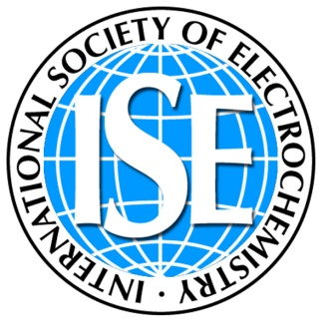 | 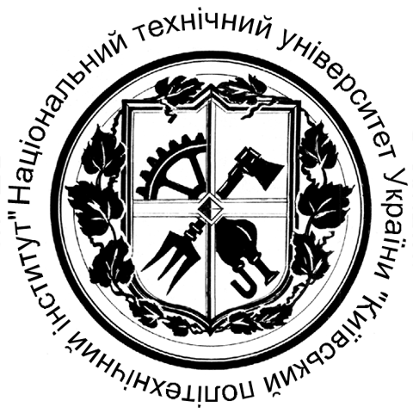

PROGRAM
2nd ISE Satellite Student Regional Symposium on Electrochemistry «Promising Materials and Processes in Applied Electrochemistry»

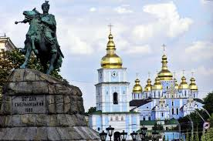
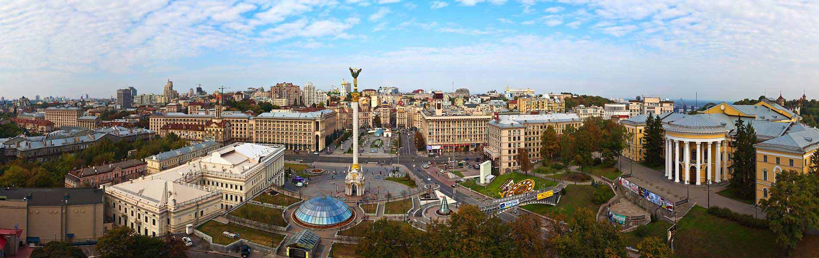

Kyiv 2017
We are very pleased to invite you to participate in the 2nd ISE Satellite Student Regional Symposium on Electrochemistry in Ukraine «Promising Materials and Processes in Applied Electrochemistry», which will be held in Kiev on May 18-19, 2017 and which takes place within the celebration of The Science Day and Europe Day in Ukraine. Its aim is to promote scientific contacts and discussions between scientists and students representing different areas of this versatile science.
We hope that the 2nd ISE Satellite Student Regional Symposium on Electrochemistry in Ukraine will be equally interesting and useful for you!
We wish the participants of Symposium to expand successfully their knowledge in electrochemical science, to receive scientific inspiration, to show their abilities and to relax a little!

INTERNATIONAL PROGRAM COMMITTEE
Chairman
Ivan GRYSHCHENKO — Prof. Dr., Rector of Kyiv National University of Technologies and Design (Ukraine);
Vice-chairmans
Viktor KAPLUN — Prof. Dr., Vice-Rector of Kyiv National University of Technologies and Design (Ukraine);
Viacheslav BARSUKOV — Prof. Dr., Kyiv National University of Technologies and Design (Ukraine);
Olga LINYUCHEVA — Prof. Dr., Igor Sikorsky Kyiv Polytechnic Institute (Ukraine);
Members
Felicia IACOMI — Prof. Dr., Alexandru Ioan Cuza University, Iasi (Romania);
Gennady TULSKY — Prof. Dr., National Technical University “Kharkiv Polytechnic Instutute” (Ukraine);
Gimi RIMBU — Dr., University of the West of England (the United Kingdom);
Ioannis A. IEROPOULOS — Prof. Dr., Bristol BioEnergy Centre, Bristol (the United Kingdom);
Janis ZICANS — Dr., Riga Technical University (Latvia);
Juozas GRAZULEVICIUS — Prof. Dr., Kaunas Technical University (Lithuania);
Marian JASKULA — Prof. Dr., Jagiellonian University, Krakow (Poland);
Mariana SPODARYK — Dr., Institute of Chemical and Engineering, Energopolis ( Valais, Switzerland);
Mirela ŞUCHEA — Dr., Technological Educational Institute of Crete (Greece);
Olexander CHERNIK — Prof. Dr., Belarusian State Technological University (Belarus);
Olga BAULA — Dr., dean of Faculty, Kyiv National University of Technologies and Design (Ukraine);
Rasa PAULIUKAITE — Dr., Vilnius Center of Physical Sciences and Technology (Lithuania);
Viktoriia PLAVAN — Prof. Dr., Kyiv National University of Technologies and Design (Ukraine)
Volodymyr NEFEDOV — Prof. Dr., Ukrainian State University of Chemical Technology, Dnepr (Ukraine);
ORGANIZING COMMITTEE
Prof. Dr. Viacheslav BARSUKOV – Chairman of organizing committee, Kyiv National University of Technologies and Design (Ukraine);
Dr. Yulia BORYSENKO – secretary of organizing committee, Kyiv National University of Technologies and Design (Ukraine);
Dr. Ilona SENYK — secretary of organizing committee, Kyiv National University of Technologies and Design (Ukraine);
Members
Dr. Victor TVERDOKHLIB — Kyiv National University of Technologies and Design (Ukraine);
Dr. Volodymyr KHOMENKO — Kyiv National University of Technologies and Design (Ukraine);
Dr. Georgy VASYLIEV — Igor Sikorsky Kyiv Polytechnic Institute (Ukraine);
Dr. Iryna MAKEEVA — Kyiv National University of Technologies and Design (Ukraine);
PhD-student Maksym KOLIADA — Kyiv National University of Technologies and Design (Ukraine);
PhD-student Oksana CHERNYSH — Kyiv National University of Technologies and Design (Ukraine);
Dr. Oleksiy KOSOGIN — Igor Sikorsky Kyiv Polytechnic Institute (Ukraine);
Dr. Olena KRYUKOVA — Kyiv National University of Technologies and Design (Ukraine);
M.Sc. Tatjana IVANOVA — Riga Technical University (Latvia);
Dr. Yulia MIROSHNYCHENKO — Igor Sikorsky Kyiv Polytechnic Institute (Ukraine);

SYMPOSIUM PROGRAM
May 18, 2017
Hall for Academic Senate, building 1, floor 4

9.00 – 10.00 | Registration of participants, posters preparation
10.00 – 10.30 | Opening ceremony
10.30-12.00 | Plenary session:
10.30-10.50 | Volodymyr Khomenko. Multifunctional Composite Materials for Alternative Energy Storage, Kyiv National University of Technologies and Design, Ukraine.
10.50-11.05 | Olena Tynkevych. Electrochemical investigation of quantum dots band structure, Yuriy Fedkovych Chernivtsi National University, Ukraine.
11.05-11.20 | Dmytro Sydorov. Electrochemical synthesis of 3-methylthiophene/3,4-ethylenedioxythiophene copolymers and their electrochromic properties, Institute of Bioorganic Chemistry and Petrochemistry, NAS of Ukraine.
11.20-11.35 | Anna Potapenko. Composition of intermediate phases showing up upon delithiation of lithium-manganese spinel, Joint Department of Electrochemical Energy Systems, Ukraine.
11.35-12.00 | Luca Pini. Electrochemistry in microscale, Scanning Electrochemical microscopy: new possibilities, new techniques, AMETEK, The Netherland.
12.00 – 12.30 | Coffee break
12.30 – 13.30 | Poster session
13.30 – 14.00 | Ceremony of Awarding and Closing
14.00 – 15.00 | Lunch break
15.00 – 17.00 | Attending the Day of the Faculty of Chemical and Biopharmaceutical Technologies of Kiev National University of Technology and Design.

Poster session:
Section 1
1.1 | Chernysh O.V. | Carbon materials for high power negative electrodes of lithium-ion batteries and capacitors
1.3 | Riabokin O.L. | The density gradient thermal aging model of the alkaline Zn-Mn batteries
1.4 | A. Katashynski,  V. Khomenko | The electrochemical reduction of oxygen on electrodeposited palladium catalyst
1.5 | Zudina L.V. | Orr study on Fe- and Co- doped manganese dioxide with ramsdellite structure
1.6 | Makyeyeva I.S. | Manganese dioxide as a cathode catalyst in metal-air cells
1.7 | Voronina O.V. | Cathode processes of hydrogen evolution on vanadium-containing materials
1.8 | Diamant V.A. | Conductivity and viscosity of tetramethylammonium bis(salicylato)borate in solutions of aprotic dipolar solvents
1.9 | Kravets Y.A. | The effect of surface modification of cathode materials on their electrochemical characteristics
Section 2
2.1 | Antsikhovich I.V. | Using pulse modes in non-chromium electrolytes for electropolishing
2.2 | Ushchapovskyi D.Yu. | The intensification of compact copper electrowinning process by increasing vertical current density and distribution uniformity
2.3 | Yermolenko I. | Functional ternary Fe-Co-Mo(W) coatings
2.4 | Ovcharenko G.V. | Dynamics of redox processes in the electrolyte for electrodeposition of Cu-Sn alloy
2.5 | Savchuk O. O. | Influence of electrolysis parameters on the properties of Ni-P alloys obtained from methanesulfonate electrolytes
Section 3
3.1 | Nyrkova L.I. | Influence of strength properties of pipe steel on its corrosion resistance and electrochemical characteristics in solutions of different corrosivity
3.2 | Tsurkan A.V. | Electrochemical synthesis of protective ceria layers using methanesulfonate electrolytes
3.3 | Vasyliev G. | The influence of ultrasound vibration on the pitting corrosion of aisi 316 stainless steel
3.4 | Kityk A.A. | Voltammetric study of corrosion of mild steel in deep eutectic solvents
Section 4
4.1 | Miroshnychenko Iu.S. | Electrochemical device for environmental safety monitoring
4.2 | Mazanka V.M. | Anode material of coulometric gas generator
4.3 | Vashchenko O.M. | Prevention of carbonization in the alkaline electrolyte of oxygen sensor
4.4 | Zinchuk O.V. | Decrease of electrochemical noise of titanium electrode
Section 5
5.4 | Louloudakis D. | The effect of growth time on the properties of lpcvd grown WO₃ thin layers for electrochromic applications
5.5 | Fomanyuk S.S. | Electrosynthesis and optical properties of cadmium selenide nanoparticles
5.6 | Shmychkova O., | Electrochemical oxidation of toxic organic aromatic substances
5.7 | Karakurkchi А. | Cobalt and manganese oxide catalytic systems on valve metals in ecotechnologies
5.8 | Kravchenko A.V. | Thermochemical and electrochemical description of the Fe-C catalytic system
5.9 | Bilous T.A. | The choice of anode material for the electrochemical synthesis of peroxyacetic acid
5.10 | Zulfigarov A.O. | Syntesis route for preparation of precursor solutions
5.11 | Ponomarouva l.n. | Electromembrane removal of toxic ions from diluted galvanic wastes using organic-inorganic ion-exchangers
5.12 | Kolomiyets Ye.A. | Ionic conductivity of granulated organic-inorganic ion-exchangers
5.13 | Butenco O.A. | Developing composite polymer shielding materials for the uhf range
5.14 | Zubchenko L.S. | Photobioelectrochemical hydrogen and electricity production from different organic wastes
5.15 | Skuodis E. | Glass-forming cyano-substituted carbazole derivatives for optoelectronics
5.16 | Pini L. | Electrochemistry in microscale. Scanning electrochemical microscopy: new possibilities, new techniques
5.17 | Grybauskaite-kaminskiene G. | Silicon-based electroactive compounds containing different donor moieties as potential hosts for organic light emitting diodes

May 18, 2017
13.30-14.00 | Ceremony of Awarding and Closing. Photographing.  Hall for Academic Senate, building 1, floor 4

For notes

