THE INFLUENCE OF IONIC DOPANTS ON INITIAL STAGES OF LEAD DIOXIDE ELECTROCRYSTALLIZATION

O. Shmychkova, T. Luk'yanenko, A. Velichenko
Ukrainian State University of Chemical Technology
o.shmychkova@hotmail.com

Electrocrystallization of PbO₂ begins with the formation of a monolayer on the electrode surface, then the formation and growth of three-dimensional nuclei takes place. The formation of one phase is noticeably lagged behind the other. At layer-by-layer crystallization and significant lagging of one of phases may occur ingesting of growing centres of one phase by another.The type of lagging phase depends on the nature of electrolyte: for nitrate bath it is β, for methanesulfonate – α.
It has been determined that the crystallization of lead dioxide from methanesulfonate electrolytes proceeds through the progressive mechanism. A preferred form of formed crystals at 2D nucleation in the case of electrolytes, based on nitric acid is a cone, and electrolytes, based on methanesulfonic acid is a cylinder. The process of coating formation of lead dioxide begins with the formation of α-phase crystals. After a certain period of time, the formation of β-phase crystals takes place. Thus, the α- and β-phases can be formed simultaneously. Predominance in the growth of one or the other phase is determined by the ratio between the kinetic constants of the crystal growth of α- and β-phases. The coatings obtained from methanesulfonate bath are almost entirely composed of α-phase. It was found for the first time that addition of dopants in deposition electrolytes leads to growth of β-phase content in deposits. The latter suggests that the phase composition is largely influenced not by the nature of the substrate but by kinetic difficulties in initial stages of crystallization depending on the composition of deposition electrolyte.

Electrodes based on lead dioxide doped by ionic additives are known to be of great interest for investigation owing to tailoring solid state properties as well as electrocatalytic activity of PbO₂ [1−3]. Particular attention should be paid to ionic additives in high oxidation states +3, and +4 (compared to places of cation vacancies of lead dioxide, in which Pb²⁺-ions are known to be localized). It is recognized [4, 5], that there are two zones on the lead dioxide surface: crystal (PbO₂) and hydrated [PbO(OH)₂], that are in equilibrium and are capable to exchange cations and anions with the ions present in the bulk. Lead ions replacement both in hydrated and crystal zone would cause not only the change of amount of oxygen-containing particles in each zone, but their binding energies, that in turn will change the electrocatalytic activity of materials.
In the present work we examine early stages of electrocrystallization of PbO₂ from methanesulfonate/nitrate electrolytes that contain various ionic additives and surfactants (Bi³⁺, Ce³⁺, Sn⁴⁺, [NiF₆]²⁻, [SnF₆]²⁻, SDS) and estimate rate constants of crystallization of α- and β- phases.
Research Methodology. Electrodeposition regularities of lead dioxide both in nitrate and methanesulfonate electrolytes were studied on Pt disk electrode by steady-state voltammetry, chronoamperometry. Voltammetry measurements were carried out in a standard temperature-controlled three-electrode cell. All potentials were recorded and reported vs. Ag / AgCl / KCl _{(sat.)}.
Results and Discussuon. Current transients for PbO₂ deposition on Pt disk electrode were obtained for investigation of initial stages lead dioxide electrodeposition from methanesulfonate electrolytes (Fig. 1). The type of transient is determined by the electrode potential. At low polarizations (E=1.55 V) the biggest induction period with a further stretched maximum of current is observed. Increasing the anodic polarization leads to a substantial decreasing the induction period and the increasing of current maximum.
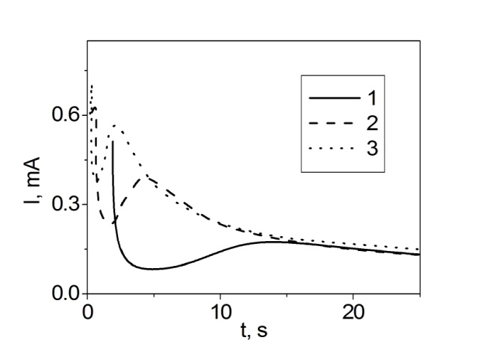 | Fig. 1. Current-time transients for PbO₂ deposition on Pt disk electrode from 0.01 M Pb(CH₃SO₃)₂+1 M CH₃SO₃H at different deposition potentials, mV: 1 – 1550; 2 – 1600; 3 – 1620

A linear relationship between the natural logarithm of the induction time of crystallization and the applied potential with negative slope is observed both for nitrate and methanesulfonate electrolytes. Such dependence shows that the electrocrystallization of PbO₂ begins with
the formation of a monolayer on the entire surface of the electrode, and then the formation and growth of nuclei occurs. Growth of lead dioxide occurs through layer-by-layer crystallization, so each following layer is formed on the renewed surface [6, 7].
An increase of a current delay corresponding to the induction time can be observed if ionic dopants are present in the deposition bath. This indicates difficulties in the initial stages of the phase formation of lead dioxide (Figs. 2, 3).
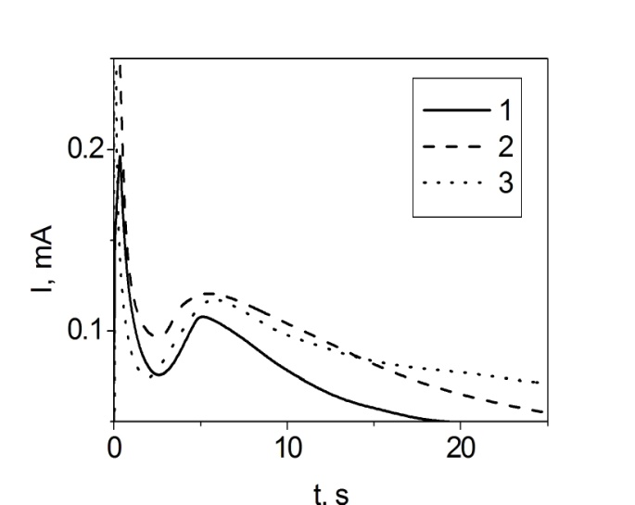 | 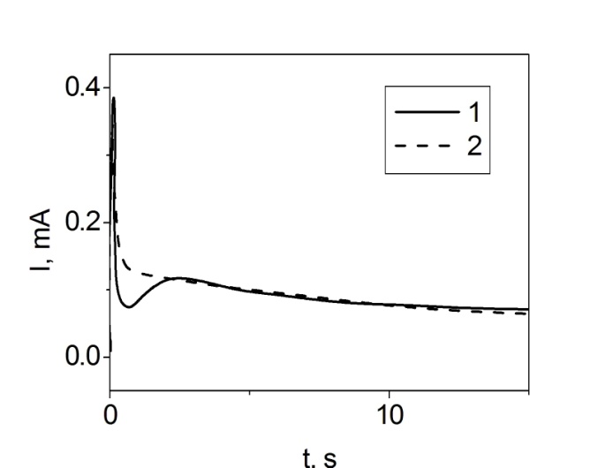
Fig. 2. Current-time transients for PbO₂ deposition on Pt disk electrode at 1620 mV from 0.01 M Pb(CH₃SO₃)₂+1 M CH₃SO₃H+X, where X is 1 – 0.01 M Bi³⁺; 2 – 0.001 M Ce³⁺; 3 – 0.01 M Sn⁴⁺ | Fig. 3. Current-time transients for PbO₂ deposition on Pt disk electrode at 1620 mV from 0.01 M Pb(CH₃SO₃)₂+1 M CH₃SO₃H+X, where X is 1 –[NiF₆]²⁻; 2 – 0.01 M [SnF₆]²⁻

For the analysis of obtained transients we used the model, described in [8], and calculated rate constants for instantaneous and progressive nucleation.
For all the above cases, the crystallization occurs through the progressive mechanism. The preferred geometric shape of formed crystals at 2D nucleation from electrolytes containing cationic additives is cone. And upon crystallization from electrolytes containing complex ions additives geometric shape changes on a cylinder. The main parameters of the crystallization of lead dioxide from electrolytes containing ionic additives are presented in the Table 1.
Table 1. Parameters of initial stages of lead dioxide electrocrystallization
Deposition electrolyte  0.01 M Pb(MS)₂+1M MSA | t_{α} | К_{α} | t_{β} | К_{β}
+0.01 M Bi³⁺ | 2.17 | 9.20×10⁻⁶ | 4.71 | 4.1×10⁻⁶
+0.001 M Ce³⁺ | 2.40 | 2.12×10⁻⁶ | 4.40 | 8.95×10⁻⁸
+0.01 M Sn⁴⁺ | 1.56 | 2.06×10⁻⁵ | 4.41 | 6.28×10⁻⁷
+0.01 M [NiF₆]²⁻ | 0.02 | 4.61×10⁻⁵ | 0.05 | 9.78×10⁻⁷
+0.01 M [SnF₆]²⁻ | 0.64 | 3.92×10⁻⁶ | 1.99 | 5.32×10⁻⁵
+ 3×10⁻⁵ SDS | 1.50 | 6.38×10⁻⁶ | 2.80 | 1.04×10⁻⁵
+ 7×10⁻⁵ SDS | 0.84 | 1.38×10⁻⁶ | 1.08 | 8.22×10⁻⁶
As one can conclude from obtained data, the presence of cations in the deposition electrolyte alters the ratio between α- and β-phase crystallization constants in different amount. Thus, in the presence of the complex ion [SnF₆]²⁻ the growth of β-phase dominates. For other cationic additives the prevalence of α-phase growth is observed. It should also be noted, that the presence of complex nickel and tin fluoride ions reduces the beginning of nucleation. Most clearly this effect is observed for [NiF₆]²⁻ ion.
It is known [9], that the surfactant additive has a significant effect on the kinetics of lead dioxide electrodeposition, without changing the mechanism of the process. It has been also found that it is incorporated into the growing coating through adsorption on PbO₂ crystals. That in turn will lead to changes in initial stages of the crystallization. Surfactant additives selectively adsorbed on certain faces, usually parallel to faces, reducing the growth rate of these faces, and thereby altering the shape of growing crystals. For more detailed analysis of surfactant additives influence on the initial stages of the crystallization current-time transients from electrolytes, containing sodium dodecyl sulfate (SDS) of two different concentrations 3×10⁻⁵ and 7×10⁻⁵ mol dm⁻³ were obtained (Fig. 4).
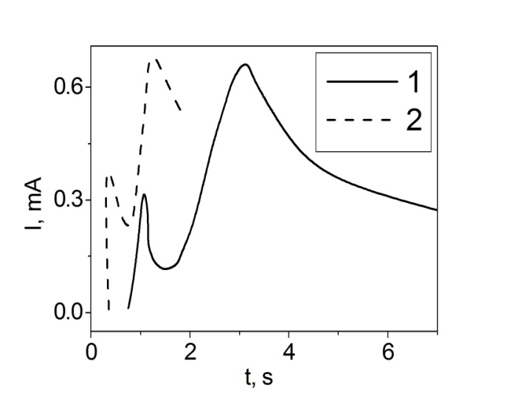 | Fig. 4. Current-time transients obtained at PbO₂ deposition on Pt electrode at 1620 mV from next solutions: 0.1 M Pb(CH₃SO₃)₂ + 0.1 M CH₃SO₃Н+3×10⁻⁵ SDS; 2 – 0.1 M Pb(CH₃SO₃)₂ + 0.1 M CH₃SO₃Н+7×10⁻⁵ SDS.

The analysis of obtained transient revealed that in the case of methanesulfonate electrolytes the crystallization proceeds according to the progressive mechanism. For nitrate electrolytes there is a change in the mechanism from progressive on instantaneous at high concentrations of surfactants. The preferred form of crystals at 2D nucleation in the presence of additives in nitrate electrolytes is semi-spheroid, and in the case of methanesulfonate electrolytes cylinder becomes the preferred form of crystals (see Table 1).
Conclusions. The nature of depositing electrolyte considerably influences on the phase composition of lead dioxide coatings and on crystallographic orientations of individual faces. The coatings obtained from methanesulfonate bath are almost entirely composed of α-phase. It was found for the first time that addition of dopants in deposition electrolytes leads to growth of β-phase content in deposits. This in turn suggests that the phase composition is largely influenced not by the nature of the substrate but by kinetic difficulties in initial stages of crystallization depending on the composition of the deposition electrolyte. Predominance in the growth of one or the other phase is determined by the ratio between the kinetic constants of the crystal growth of α- and β-phases.

References
[1] Li X. Electrodeposited lead dioxide coatings / X. Li, D. Pletcher, F.C. Walsh // Chem. Soc. Rev. 2011. – Vol. 40. – P. 3879-3894.
[2] Chaplin B. P. Critical review of electrochemical advanced oxidation processes for water treatment applications / B. P. Chaplin // Environ. Sci.: Processes Impacts. – 2014. – Vol. 16. – P. 1182-1203.
[3] Low C. T. J. The electrodeposition of highly reflective lead dioxide coatings / C. T. J. Low, D. Pletcher, F. C.Walsh // Electrochem. Commun. – 2009. – Vol. 11. – P. 1301-1304.
[4] Ruetschi P. On the presence of OH⁻ ions, Pb²⁺ ions and cation vacancies in PbO₂ / P. Ruetschi, R. Giovanoli // Power Sources. – 1991. – Vol. 13. – P. 81-97.
[5] Pavlov D. The PbO₂ Particle: exchange reactions between ions of the electrolyte and the PbO₂ particles of the lead-acid battery positive active mass / D. Pavlov, I. Balkanov // J. Electrochem. Soc – 1992. – Vol. 139. – P. 1830-1835.
[6] Electrocrystallization of lead dioxide: influence of early stages of nucleation on phase composition / O. Shmychkova, T. Luk'yanenko, A. Piletska [et al.] // J. Electroanal. Chem. – 2015. – Vol. 746. – P. 57-61.
[7] The influence of deposition conditions on phase composition of lead dioxide-based materials / O. B. Shmychkova, T. V. Luk’yanenko, A. B. Velichenko [et al.] // Prot. Met. Phys. Chem. Surf. – 2015. – Vol. 51. – P. 593-599.
[8] Electrocrystallization of lead dioxide: Analysis of the early stages of nucleation and growth / M. Y. Abyaneh, V. Saez, J. Gonzalez-Garcia [et al.] // Electrochim. Acta. – 2010. – Vol. 55. – P. 3572-3579.
[9] Nafion effect on the lead dioxide electrodeposition kinetics / A. B. Velichenko, T. V. Luk’yanenko, N. V. Nikolenko [et al.] // Russ. J. Electrochem. – 2007. – Vol. 43. – P. 118-120.

